ACTIVITY: Maintenance of top charging sysytem

Objective : - Safe working in top charging system
Scope : - Blast Furnace Accessories
Ref. : -SP 44 ,WI / MAINT 91
Responsibility : - Engineer in charge & workmen on the job
PPE s to be used: Helmet, Safety shoes, hand gloves, safety belt, Co monitor, safety goggle,
Aspect / Impact
Scrap generation | Resource Depletion
Oil Spillage | Land contamination
Oil traced waste generation | Land contamination & Resource Depletion
Fumes | Health
Fire | Air pollution SP 42
Hazards identified :
Physical Hazard -
- Pressure
- temperature
- fall of oil in eyes, ears, mouth
- Explosion while gas cutting/welding
Mechanical Hazard -
- Trapping between two objects
- Fall of material, hammer, tools, slinged items, bolts, wedges
- Fall of person from platform,
- Entanglement
- Impact of moving / slinged items, portable tools, chuck,
- Failure of welding hook.
- Toppling of derrick
- Fall of counter weight
- Fall of person through opening of platform
Chemical hazard -
- Gas poisoning,
- Fire
Electrical hazard -
- electrical shock
Human Hazards :
- Alcoholism,
- casual approach of operator
- non usage of PPE?s

Activity 1 | Dismantling, Erection and Commissioning of Top charging System
Activity 2 | Maintenance of Bleeder Valve
Activity 3 | Equilisation Valve Maintenance
Activity 4 | Rotary Hopper Maintenance
Activity 5 | Furnace Top Hatch Opening/Closing during Shutdown
Activity 6 | Procedure for furnace top sprays checking/Changing
Activity 7 | Stock Rod Fixing

ACTIVITY 1 - DISMANTLING, ERECTION AND COMMISSIONING OF TOP CHARGING SYSTEM
Work No 1 : Dismantling of top charging equipment
Work No 2 : Erection and commissioning of top charging equipment
Work No 3 : Upper bell cylinder replacement
Work No 4 : Lower bell cylinder replacement
Work No 5 : Upper bell and seat replacement
Work No 6 : Checklist for Furnace top charging equipment assembly
Work No. 7: Upper bell replacement with split seat.
Work No 8 : Wear Rings Replacement

Work No 1: Dismantling of top charging equipment
- Take production clearance & work permit for this activity.
- Check f/c top 5-ton BF2/ 6T BF1 hoist for safe working, check for smooth operation of hoisting & cross travel. Check the brake of the hoist before lifting any item.
- Take shut down of top power pack 60 hp & 5 hp pumps, rotary distributor, conveyer belt no 5, & auto stock rod.
- Ensure proximity switches are removed by electrical.
- Keep lower bell in closed condition & upper bell in open condition.
- Dismantle the motor & gearbox of rotary drive & remove all wear rings on hollow shaft.
- Remove all dust protection covers of rotary hopper.
- Open all inspection doors and take out door cover.
- Lock the lower bell with basin with 2ton turnbuckle at four-cleat location. Inspect for wear out of cleats, if so weld new cleats.
- Make circular platform / gratings in 2/3 pieces to work inside with bolted / welded arrangement. Workmen working inside should stand on the platform / grating while disconnecting shaft / upper bell. (recommended for better working)
- Lock properly rotating & stationary part of rotary hopper.
- Make gas cut holes in the rotary chute at appropriate location to put slings. Never weld cleats on hard-faced surface. All care must be taken to take out loose parts of revolving distributor during dismantling/erection.
- Pass sling from the gas cut holes on rotary hopper top chute & hold with 5-ton / 6T hoist & dismantle the two halves of top chute.
- Disconnect the hoses of upper /lower bell cylinders. Ensure upper bell cylinder is in lowered condition before removing the hydraulic hoses.
- Plug the cylinder ports & interconnect opened hoses with nipple. Tag pipelines with appropriate name to identify the lines.
- Remove the lower bell top canopy by gas cutting.
- Tie the short connecting rod before removing the clamp with rope.
- Disconnect the clamp connecting long & short connecting rod & keep short connecting rod inside the bell. If clamp cannot be opened than gas cut the small connecting rod below the clamp.
- Fix back connecting rod holding clamp only on lower part of long connecting rod to avoid lowering of hollow shaft.
- Cut the upper bell in two halves.
- Hold hollow pipe with 3T chain block, & dismantle the two tie rods of upper bell.
- The platform, which is opened for taking out the shaft, must be cordoned to avoid fall of man/material.
- Disconnect the pins of lower bell cylinder with long connecting rod.
- Use gauging electrode to cut the pin incase it is tight on shaft.
- All care must be taken while slinging the shafts to avoid slipping.
- Gas cut all foundation bolts of rotary hopper & ensure punching out of all gas cut bolts.
- Hold firmly rotary hopper gear assembly & liner with 5ton/ 6T hoist, lift & take out &lower in the cast house.
- Remove rotary hopper gearbox platform & take out.
- Gas cut all bolts of fixed hopper & punch the bolts. Lift with 5 ton/ 6T hoist & lower in the cast house. Check all welded cleats for safe lifting.
- Gas cut all bolts of charging hopper on crown ring , ensure punching out of all bolts.
- Hold charging hopper firmly with proper slings with 5-ton/ 6T hoist.
- Slowly hoist 5-ton/ 6T crane & check for break functioning. If ok, shift to outside area & lower in the cast house area.
- Gas cut the fixed distributor into 2 pieces. Take out by holding on the 5T/6T hoist.
Work No 2 :Erection and commissioning of top charging equipment
- Erect the fixed distributor with square bar as per drawing & weld to the furnace with 7018 welding rods. Suitable platform has to be made for safe working.
- Apply castable FH- 14 after welding the square bar. Remove the inside platform.
- Check for zero water leveling of crown ring.
- Put 24mm asbestos round rope 3 rounds by applying holdtite in inside circle of crown ring.
- Erect lower bell with basin with 5-ton/ 6T hoist & center on crown ring. Put 24mm asbestos round rope 3 rounds by applying holdtite.
- Erect charging hopper on top of basin & insert all M24 studs in ring holes. Check for water leveling. Apply 20mm asbestos round rope 3 rounds on top flange of charging hopper with holdtite.
- Tighten all bolts.
- Erect upper bell basin with seat on hopper. Check for water leveling. Apply 20mm asbestos round rope 3 rounds with holdtite & erect fixed hopper. Tighten all bolts Please ensure that Orientation of Rotary hopper gearbox frame in such a position that it should obstruct both stock rod assemblies
- Erect rotary hopper & tighten all bolts.
- Erect short connecting rod & connect it with lower bell with 35T D shackle,
- Place protection covers on top of it & bolt it.
- Insert long connecting rod with hollow pipe & couple it with clamp to short connecting rod.
- Connect the lower bell cylinder with long rod with the pin.
- Connect the hollow pipe to the upper bell cylinder with tie rods & clamps.
- Connect the upper bell in two halves to the hollow shaft. Place the wear rings 22 sets and on top fit two clamps of width 50 mm(approx) as per the gap remaining between clamp & topmost wear ring set. This is to prevent wear rings from falling out in operation.
- Erect rotary hopper top chutes in two halves & tighten all bolts.
- Check alignment of lower bell for proper centering with basin after full tightening of crown ringbolts.
- Align rotary hopper & drive.
- Erect equalization valves 1 & 2 on the platform & connect the piping. Ensure that the hoses of cylinder are not rubbing against each other and are not bend.
- Connect the hoses of lower bell & upper bell cylinders after flushing of pipelines. Use asbestos wrapped hoses at furnace top to avoid failure of hose in case of fire at furnace top. Item code: (1702010052 – 1” x 2 mtrs / 1702010040 – 1/2” x 1 mtrs / 1702010038 –1/ 2” x 1.5 mtrs)
- Take trial of lower bell & upper bell. Check for proper centering.
- Quality of gasket jointing to be strictly ensured during bell changing activity.

After BF1 relining in April 2012 crown ring flange gas leakage took place towards BF2 side and shutdown was taken for 2.66hrs on 16.11.12.
To prevent such breakdown again preventive actions mentioned below are to be followed.
After replacing top charging equipments taken furnace shutdown and check all studs of crown ring and fixed hopper connecting charging hopper tightness checking to be done in the following way
- 36 to 48 hrs after starting BF
- 1 month after starting BF
- There after every 6 months.

Work No 3 : Upper bell cylinder replacement
1. Take production clearance & work permit for this activity.
2. Ensure upper bell is empty
3. Check f/c top 5-ton/ 6T hoist for safe working, check for smooth operation of hoisting & cross travel. Check the brake of the hoist before lifting any item.
4. Ensure upper bell is closed
5. Take shut down of top charging power pack 60 hp pump 1 & pump 2, 5 hp pump 1 & pump 2, rotary distributor & CB5
6. Ensure limit switches are removed by Instrumentation.
7. Cut out bracket fitted on the adaptor showing open & close signal.
8. Put ISMB 200, 500 mm long piece 10mm plate welded on both sides in between upper bell swiveled bracket & horizontal structure.
9. Make it in centre vertically plumb & stich weld on the structure.
10. Slowly loosen closing hose pipe of upper bell cylinder so that piston rod will come down with gravity till it touches the vertical fabricated beam.
11. Tag weld on the top side of the fabricated beam with the swiveled bracket.
12. Remove both the hose pipes & fittings from the cylinder & put 1 plug.
13. Put 2T/3T chain block on the top monorail/beam, hook to be put on the cylinder with sling.
14. Remove bottom pin connecting swiveled bracket & adaptor.
15. Take cylinder load on chain block & remove eye end pin.
16. Lower the cylinder on the platform & hoist new cylinder in position.
17. First put eye end pin (Apply anti seize – C5A compound to the pin before inserting), than remove chain block & sling on the cylinder.
18. Put pin (Apply anti seize compound to the pin before inserting), connecting swiveled bracket & adaptor.
19. Connect both the hoses & fittings of upper bell (keep hose slightly loose to release air from pipe), replace dowty seals.
20. Using chain block hold the swiveled bracket & remove the beam put between structure & swiveled bracket.
21. After removing beam release the chain block slowly, piston rod will come down, opening upper bell.
22. Re-weld bracket fitted on the adaptor showing open & close signal in presence on instrumentation.
23. Clear 60hp pumps shutdown.
24. Close & open upper bell cylinder to release the air in the line, once air is fully removed tighten fully the hose pipes & fittings.
25. Take trial for 20 times to check out smooth functioning of the cylinder.
26. Cylinder to be checked for wiper seal leakage by taking trials & lowering after closing of cylinder in monthly planned shutdown. Also oil leakages if any to be checked & attended.
27. Counter balance valve to be replaced in every relining.
Work No 4: Lower bell cylinder replacement
- Take production clearance & work permit for this activity.
- Ensure lower bell is empty
- Check f/c top 5-ton/ 6T hoist for safe working, check for smooth operation of hoisting & cross travel. Check the brake of the hoist before lifting any item.
- Ensure lower bell is closed
- Take shut down of top charging power pack 60 hp pump 1 & pump 2, 5 hp pump 1 & pump 2, rotary distributor & CB5
- Ensure limit switches are removed by Instrumentation.
- Cut out bracket & guide rod fitted on the adaptor showing open & close signal.
- Put 3T chain block to hold long shaft of lower bell
- Slowly loosen closing hose pipes of lower bell cylinder
- Remove both the hose pipes & fittings from the cylinder & put 1 plug.
- Put 2T chain block on the top monorail/beam, hook to be put on the cylinder with sling.
- Remove bottom pin connecting swiveled bracket & adaptor.
- Take cylinder load on chain block & remove eye end pin.
- Lower the cylinder on the rotary hopper platform & hoist new cylinder in position.
- First put eye end pin (Apply anti seize compound C5A to the pin before inserting), than remove chain block & sling on the cylinder.
- Put pin (Apply anti seize compound to the pin before inserting), connecting swiveled bracket & adaptor.
- Connect both the hoses & fittings of lower bell (keep hose slightly loose to release air from pipe), replace dowty seals.
- Re-weld bracket & rod fitted on the adaptor showing open & close signal in presence on instrumentation.
- Clear 60hp pumps shutdown.
- Close & open lower bell cylinder to release the air in the line, once air is fully removed tighten fully the hose pipes & fittings.
- Take trial for 20 times to check out smooth functioning of the cylinder.
22. Cylinder to be checked for wiper seal leakage by taking trials & lowering after closing of cylinder in monthly planned shutdown. Also oil leakages if any to be checked & attended.
23. Counter balance valve to be replaced in every relining.

Work No 5 : Upper bell and seat replacement
Entering into charging hopper is a confined Space Activity. Below mentioned procedure to be followed

FOR MORE DETAILS REFER CENTRALISED CONFINED SPACE ENTRY SOP-VL/IMS/VAB/SP44 Y

- Before Entering in Confined Space ensure –
- inside temperature should be less than 40 degree Celsius.
- CO Level should be 0 ppm
- Attendant must ensure proper illumination, if illumination not found ok, he must inform concern electrical person to provide hand lamp or halogen.
- Take the work permit from production-in-charge, Safety, electrical, mechanical for entering Confined Space.
- The workmen (Entrant) who is trained and certified by SBU Head and having valid confined space gate pass should perform the activity and he can be replaced(in emergency) only by certified entrant .
- A standby (attendant) who is trained and certified by SBU Head and having valid confined space gate pass should perform the activity and he can be replaced(in emergency) only by certified attendant .
- Standby person who shall be positioned outside the confined space , must have no other duties other than monitoring people and conditions inside the confined space and coordinating with rescue personnel (he must have contact number of rescue team members) if required.
- Standby (Attendant) person has to log down the In/Out entry of all entrants and ensure that entrant should be come out after 30 minutes from confined space for normal jobs.
- In some cases In/Out time may be relaxed /extended based on the risk involved in the particular confined space.
- Check Internal atmosphere of the space for sufficient oxygen content (19.5% to 23.5 %) flammable gases and vapours, and the potential for toxic air contaminants by the use of multi gas detector, if required use pump with extension before entering. If there is any deviation, do not enter into confined space.
- Check for the presence of Chemical asphyxiates such as Carbon monoxide (CO gas detector).It should be 0 PPM
- Check inside temperature and it should be is in the tolerable range (25 deg C to 45 Deg C). If the temperature is not within limits then appropriate ventilation to be used to normalize the temp.
- Check for suitability of equipment that is used at the confined space.
- Check any dust due to which visibility is reduced or respiratory tract is irritated.
- The sign-in and sign-out of all persons entering into confined Space should be recorded.
- Use 24V DC supply illumination to avoid electrocution/electric shock.
- Cutting or welding jobs inside the confined space should be carried out after checking for any explosive environment (LEL should be <10%) and by providing localized suction or heavy duty exhaust systems to prevent accumulation of gases inside the space.
- Isolation of related equipment of respective confined space with personal LOTO lock to be Ensured.
Please note that this area is considered as Confined Space so needs to maintain the checklist of the activity. All In time and out time details of entrants, levels of gases to be logged in checklist (yellow copy) or in any alternate document and to be documented.

Role of Rescue Team
As the work is being carried out inside confined Space, in an emergency victim can be taken out by use of rescue apparatus such as stretcher. However attendant should call ambulance which is fully equipped. However rescue team members should take a charge of the situation.

1. Take production clearance & work permit for this activity.
2. Ensure both bells are empty.
3. Take trial of upper & lower bell, keep EV1 open, EV2 close, upper bell open & lower bell close.
4. Take shutdown of 60hp pump 1 & 2, 5 hp pump 1 & 2, CB5 & Rotary hopper.
5. Take trials of 5T / 6T hoist to shift new bell & basin on furnace top.
6. Start opening both inspection doors of charging hopper, carry 2 nos CO monitors.
7. Lock long shaft with 3T chain pulley block
8. Ensure lower bell & basin hooks are in good condition & in line to fit turn buckles.
9. If hooks are worn out weld new hooks.
10. If hooks are not in line cut guide & limit switch bracket welded on lower bell cylinder fork, loosen lower bell opening hydraulic pipe connection before counterbalance valve & lower lower- bell slightly to rotate piston rod to align hooks with 100mm pipe wrench.
11. After aligning hooks ensure lower bell is touching the basin by tightening chain pulley block.
12. Fill sand / mud in seating area to avoid gas leakage and heat
13. Provide one air line hose inside for cooling and ventilation
14. 2 skilled persons should enter charging hopper wearing gas mask & fix turn buckles (4 nos) for lower bell & lower bell basin across the hooks provided. Place 2 nos angle 65x65x8 mm (3500 mm long) across the inspection doors for making working platform, by using aluminium / steel grating across the angles. Lock the grating with angle.
15. Provide 2 holes (180 degrees apart) for upper bell for slinging manila rope & gas cut the upper bell above the hole near hollow shaft fitting area keeping some portion at mating of both bells
16. Cut one side bell portion before the mating portion & other half with the mating portion, care to be taken for holding the bell with manila rope.
17. Remove bell through inspection door. Check whether seat can be inserted into the charging hopper inspection door else cut top portion of inspection door. Weld back the removed portion after inserting the seat. Check leveling of flange face while setting.
18. Gas Cut all bolts of upper bell seat except 2 nos on opposite side, punch all bolts out.
19. Fix 2 nos of new bolts opposite to each other keeping it loose cut remaining 2 nos bolts & punch out.
20. Hold the seat with a manila rope, lower slowly & take out through charging hopper.
21. Lift upper bell in two halves, using 5T/ 6T hoist shift at top hatch platform level. Ensure that slings are put on the holes provided on inside of bell & not on the cleat welded outside on the bell.
22. Open the cover of lower bell D shackle by gas cutting all 6 bolts.
23. Loosen lower bell opening hydraulic pipe connection before counterbalance valve slightly and allow the cylinder to lower. Release the chain pulley block and ensure 4 turn buckles are taking the load and the load on D shackle is released.
24. Loosen the nut of D Shackle pin & remove it, incase nut is not getting loosened remove pin connecting d shackle if not getting loosened gas cut. Insert new seat by slightly moving the small shaft to one side. If not getting shifted loosen lower bell opening hydraulic pipe connection before counterbalance valve slightly and Tighten the chain pulley block to make gap of around 100 mm Insert new seat with metallic gasket through the gap and bolt with mating upper bell cone flange. Tighten all bolts. Connect the lower bell with shaft using D shackle, pin & cover. Tighten the hoses of cylinder.
25. Weld plain plate & plate with tapping of M24 on both halves of bell close to each other on both the sides of joint.
26. Gas Cut & punch bolts remaining from inside of left over upper bell.
27. Make holes on remaining portion of upper bell both sides 180 degrees apart. Use jacking facility made out of M24 HT bolts by tightening . Take out the removed bell part.
28. Take measurement of seating area of hollow shaft. Grind the grooves to match with bell seating. Lift one half of bell using manila rope of 1 inch and hold it. Use another manila rope and lift the other half of bell and bolt each other.
29. Tighten all the bolts. Check the gap between two halves of the bell, by inserting 0.05mm filler gauge.
30. Take out the turn buckles remove the chain pulley block, clear one 60 hp pump shutdown and take upper bell trial.
31. Fix guide & limit switch bracket of lower bell in position if removed.
32. Close both the charging hopper inspection doors, clear all shutdowns take trials.
33. Close top hatch with production clearance & clear work permit.

Work No. 7 : Upper bell replacement with split seat
Entering into charging hopper is a confined Space Activity. Below mentioned procedure to be followed

FOR MORE DETAILS REFER CENTRALISED CONFINED SPACE ENTRY SOP-VL/IMS/VAB/SP44 Y

- Before Entering in Confined Space ensure –
- inside temperature should be less than 40 degree Celsius.
- CO Level should be 0 ppm
- Attendant must ensure proper illumination, if illumination not found ok, he must inform concern electrical person to provide hand lamp or halogen.
- Take the work permit from production-in-charge, Safety, electrical, mechanical for entering Confined Space.
- The workmen (Entrant) who is trained and certified by SBU Head and having valid confined space gate pass should perform the activity and he can be replaced(in emergency) only by certified entrant .
- A standby (attendant) who is trained and certified by SBU Head and having valid confined space gate pass should perform the activity and he can be replaced(in emergency) only by certified attendant .
- Standby person who shall be positioned outside the confined space , must have no other duties other than monitoring people and conditions inside the confined space and coordinating with rescue personnel (he must have contact number of rescue team members) if required.
- Standby (Attendant) person has to log down the In/Out entry of all entrants and ensure that entrant should be come out after 30 minutes from confined space for normal jobs.
- In some cases In/Out time may be relaxed /extended based on the risk involved in the particular confined space.
- Check Internal atmosphere of the space for sufficient oxygen content (19.5% to 23.5 %) flammable gases and vapours, and the potential for toxic air contaminants by the use of multi gas detector, if required use pump with extension before entering. If there is any deviation, do not enter into confined space.
- Check for the presence of Chemical asphyxiates such as Carbon monoxide (CO gas detector).It should be 0 PPM
- Check inside temperature and it should be is in the tolerable range (25 deg C to 45 Deg C). If the temperature is not within limits then appropriate ventilation to be used to normalize the temp.
- Check for suitability of equipment that is used at the confined space.
- Check any dust due to which visibility is reduced or respiratory tract is irritated.
- The sign-in and sign-out of all persons entering into confined Space should be recorded.
- Use 24V DC supply illumination to avoid electrocution/electric shock.
- Cutting or welding jobs inside the confined space should be carried out after checking for any explosive environment (LEL should be <10%) and by providing localized suction or heavy duty exhaust systems to prevent accumulation of gases inside the space.
- Isolation of related equipment of respective confined space with personal LOTO lock to be Ensured.
Please note that this area is considered as Confined Space so needs to maintain the checklist of the activity. All In time and out time details of entrants, levels of gases to be logged in checklist (yellow copy) or in any alternate document and to be documented.

Role of Rescue Team
As the work is being carried out inside confined Space, in an emergency victim can be taken out by use of rescue apparatus such as stretcher. However attendant should call ambulance which is fully equipped. However rescue team members should take a charge of the situation.

Split seat should be used only when upper bell is changed by taking 24 hrs shut down of the furnace. If gunning, relining or shortcreting is done.
1. Take production clearance & work permit for this activity.
2. Ensure both bells are empty.
3. Take trial of upper & lower bell, keep EV1 open, EV2 close, upper bell open & lower bell close.
4. Take shutdown of 60hp pump 1 & 2, 5 hp pump 1 & 2, CB5 & Rotary hopper.
5. Take trial of 5T / 6T hoist to shift new bell &split seat on furnace top.
6. Start opening both inspection doors of charging hopper, carry 2 nos CO monitors.
7. Lock long shaft with 3T chain pulley block
8. Fill sand / mud in seating area to avoid gas leakage and heat
9. Provide one air line hose inside for cooling and ventilation
10. 2 skilled persons should enter charging hopper wearing gas mask .Place 2 nos angle 65x65x8 mm (3500 mm long) across the inspection doors for making working platform, by using aluminum / steel grating across the angles. Lock the grating with angle.
11. Provide 2 holes (180 degrees apart) for upper bell for slinging manila rope & gas cut the upper bell above the hole near hollow shaft fitting area keeping some portion at mating of both bells
12. Cut one side bell portion before the mating portion & other half with the mating portion; care to be taken for holding the bell with manila rope. Remove cut upper bell through inspection door.
13. Gas Cut all bolts of upper bell seat except 2 nos on opposite side, punch all bolts out.
14. Fix 2 nos of new bolts opposite to each other keeping it loose cut remaining 2 nos bolts & punch out.
15 Hold the seat with a manila rope , lower slowly & take out through charging hopper.
16. Lift upper bell in two halves, using 5T/ 6T hoist shift at top hatch platform level. Ensure that slings are put on the holes provided on inside of bell & not on the cleat welded outside on the bell.
17. Insert new split seat in two halves. Assembly the split seat. Lift the assembled split seat with metallic gasket and bolt it with mating upper bell cone flange. Tighten all bolts.
18. Weld plain plate & plate with tapping of M24 on both halves of bell close to each other on both the sides of joint.
19. Gas Cut & punch bolts remaining from inside of left over upper bell.
20. Make holes on remaining portion of upper bell both sides 180 degrees apart. Use jacking facility made out of M24 HT bolts by tightening. Take out the removed bell part.
21. Take measurement of seating area of hollow shaft. Grind the grooves to match with bell seating. Lift one half of bell using manila rope of 1 inch and hold it. Use another manila rope and lift the other half of bell and bolt each other.
22. Tighten all the bolts. Check the gap between two halves of the bell, by inserting 0.05mm filler gauge.
23. Close both the charging hopper inspection doors, clear all shutdowns take trials.
24. Close top hatch with production clearance & clear work permit.

MATERIAL REQUIRED FOR REPLACING UPPER BELL AND SEAT:
� Upper bell & basin
� Pins & wedges of 500 mm inspection doors � 10 nos
� New hooks for lower bell (4 nos as per drawing) & basin (4 nos as per drawing)
� Welding rods to weld hooks.
� Turn buckles 4 nos for lower bell to basin with both sides high tension bolts.
� CO monitors 2 nos
� 3T chain pulley block
� 3T Slings for chain pulley block & long shaft � 3 nos.
� Pipe wrench 2 nos to loosen hydraulic pipe.
� Pipe wrench 100mm with pipe 2 nos big size to rotate long shaft
� Gas mask 4 nos.
� Air line header to fit gas mask.
� Big hammer for removing wedges of inspection doors
� Air hose 1/2� x 15 mts 2 nos
� Angle 65 x65 x 3500 mm 2 nos
� 25mm manila rope
� Bari to punch bolts
� Lower bell connecting cover with bolts
� Pin connecting D shackle to short shaft
� 30 mm plate with M24 mm tapping � 2 nos & 30mm plain plate 2 nos (60x60mm)
� 0.05mm filler gauge
� 16mm non asbestos rope with holdtite for inspection door.
Follow the house keeping procedure as per work instruction WI/MAINT/91
DO :
- Remove all manpower from bottom area including cast house.
- Nobody should stand on bottom platform while lifting or lowering of top charging items.
- Top platform chequered plate cutting should be put back while working on top platform.
- Use proper size slings & D shackles of rated capacity.
- Check proper functioning of 5-ton/ 6T hoist, & its break functioning.
- Keep all persons away in cast house while erection activity in progress.
- Fix "work in progress" tape around the working area.
- Use proper welding electrode while welding on the hard-faced area.
- Use certified chain block for safe working.
- Cover the opened plate near bell cylinder platform.
- Keep 2 nos CO monitors & keep monitoring Co gas.
- Erect the erection platform at cast house for easy material handling.
- Use gas mask while working inside charging hopper.
DO NOT :
- Allow any loose parts, tools to fall down.
- Perform cutting activity without barricading down area.
- Weld lifting lugs on hard-faced area.
- Lean over the working platform.

CHECKLIST FOR FURNACE TOP CHARGING SYSTEM ASSEMBLY
SR NO | ROTARY HOPPER PART DESCRIPTION | TO CHECK
1 | Crown ring | Water level readings to check at mininmum 4 points with one point as reference. 24mm asbestos round rope with holdtite to apply 03 rounds
2 | Lower bell and basin | Centering of bell with basin to make on level ground and tighten all 4 nos of turn buckles. Apply 24 mm asbestos round rope with holdtite 03 rounds.D shackle locking bolt should be tightened properly with cotter pin and nut to be tack welded.
3 | Charging hopper | All studs of 24mm (HTS) to be tightened equally and put lock nuts. Apply 20mm asbestos rope on top flange of charging hopper 03 rounds.
4 | Upper bell cone | Upper bell seat to fit on cone with HTS bolts and tightened with lock nuts. Metallic gasket to put in between upper bell seat and cone flange. Apply 20mm asbestos rope round on top flange of cone 03 rounds.
5 | Upper bell | All bolts to be used of HTS and tightened. Tack welding of nut with bolt to be done.
6 | Fixed hopper | All bolts to be used of HTS and tightened with lock nuts. Position of gear box mounting frame o fixed hopper to be alligned properly to prevent obstruction with stock rod and auto stock rod.
7 | Base for rotary chute open type | Tighten all bolts and should have 2 plain washer, 1 spring washer and double nuts. Bolts to be used of high tension .
8 | Vertical thrust roller assembly | Position of roller in bracket. Grease nipple should face outward and taper slant portion of roller should be inward. Check rotation of all rollers. All rollers to be replaced in every 3 months
9 | Bracket for vertical thrust roller assembly | Tighten all bolts and should have 2 plain washer, 1 spring washer and double nuts. Bolts to be used of high tension .Taper slant portion of bracket should be facing outwards.
10 | Liner for vertical thrust roller | welding to be done on top of nut with bolt after tightening all bolts. All bolts to be used of HTS.
11 | Base for mounting horizontal roller liner and liner | Tighten all bolts and should have 2 plain washer, 1 spring washer and double nuts. Bolts to be used of high tension .
12 | Ring for fixing the horizontal thrust roller assembly | Tightness of all HTS allen head bolts
13 | Horizontal thrust roller assembly | Fit the roller with slot portion on shaft and grease nipple upwards.check roller rotation.
14 | Top guide plate for Horizontal thrust roller | locking plate to weld to prevent roller shaft from rotating and making the base hole oblong
15 | Main Gear | All teeths of gear and tighten joint bolts
16 | Intermediate stool | Tighten all bolts and should have 1 plain washer, 1 spring washer. Bolts to be used of high tension .
17 | Connector for intermediate stool | Tighten all bolts and should have 2 plain washer, 1 spring washer and double nuts. Bolts to be used of high tension .
18 | Upper Cone and lower cone | Tighten all bolts and should have 2 plain washer, 1 spring washer and double nuts. Bolts to be used of high tension . Check gap (min 20mm) between hollow shaft and chute while rotating. Weld vertical supports of 65 x 65 ISA connecting stool and upper cone chute
19 | V-600 gear box | Check play in input and output shaft, coupling bushes, coupling locking bolt on shaft and bolts for tightness. Check oil level of gear box. Grease bearings in every planned shutdown to avoid failure of top bearing. Assembled gearbox trial to be taken in machine shop trial bed for 48 hrs before installing. Gear box foundation bolts should have plate washer, plain washer ,spring washer and lock nuts
20 | small shaft | Small shaft to D shackle connecting pin shoud be tightened properly with cotter pin.
21 | Canopy for Lower bell hook protection | All bolts to be used of HTSand tightened with lock nuts.
22 | long shaft | small and long shaft connecting clamp to be tightened with HTS bolts and lock nuts
23 | Hollow shaft | Gland rope 12 mm as per drawing no. 12000148 to put on top and bottom of shaft during assembly with long shaft. Ensure lantern rings are inserted in between 2 rounds of gland rope as per drawing.
24 | Clamp for upper bell connector pipe | All bolts to be used of HTS and tightened with lock nuts.
25 | Tie rods | After setting of Upper bell closing /opening lock nuts of tie rod to be tightened and tack welded to tie rod holder
26 | Bell cylinders | Cylinder connecting Pin nuts to be tightened and locked with cotter pin.
27 | Top hatch | 12mm asbestos rope to be replaced every time when hatch is opened. Use wedge pin as per dr no PIP-3-0307 Rev-C only.
Work No 8 : Wear Rings Replacement:
- Take clearance from Production department
- Take electrical shutdown of CB#5 (both Motors), 60 HP Both, 5 HP both pumps & Rotary Hopper
- Safety Harness compulsorily to be used while working in rotary hopper chute
- Loosen clamp bolts at both ends
- Check for worn out of wear rings
- Remove one set by one set wear ring till worn out wear ring
- Insert new wear rings one set by one set
- On top fit two clamps of width 50 mm(approx) as per the gap remaining between clamp & topmost wear ring set. This is to prevent wear rings from falling out in operation.
- Take trial of rotary cone after fixing wear rings. Check gap (min 20mm) between hollow shaft and chute while rotating.
- Again take shutdown of rotary hopper & put all wear rings in position & check for rotary chute touching the wear ring, in case it is touching using gauging rod – (1902030024 - ELECTRODE,AS,LOTHERME 801,4MM) gauge the portion touching the wear ring, again check the clearance by rotating the cone with hand.

ACTIVITY 2 : MAINTENANCE OF BLEEDER VALVE
Work No 1 : Replacing bleeder seat & cap
Work No 2 : Bleeder counter weight changing
Work No 3 : Bleeder wire rope changing
Work No 4 : Electric winch operation
Work No 5 : Electric winch maintenance
Work No 6 : Bleeder bush replacing
Work No 7 : Bleeder belly velly washers and disc spring screw assembly to replace
Work No 8 : Bleeder seal to replace
Work No 9 : Cutting and welding of uptake & down comer
Work No 10 : Bleeder monkey ladder replacement
Work No 11 : Bleeder arm changing
Work No 12 : Down comer leakage arresting with Crane and working cage.
- Take clearance from production department (Work Permit) from the shift Superintendent / in charge.
- Clean the bleeder valve using compressed air.
- There is no clearance to work in bleeder & its accessories when following activities are in progress:
- tuyere changing
- working inside bell
- Working inside rotary hopper chute
- Working inside dust catcher
Work No 1 : Replacing bleeder seat & cap
1. Take production clearance
2. Bleeder valve should be operated only by production engineers
3. At any given time second bleeder should be kept open with mechanical lock (40 dia rod insertion in matching hole) on bleeder at bleeder platform
4. Lock the bleeder arm which holds cap in open condition manually by inserting 40 dia rod carefully
5. Keep dummy plate over the bleeder seat to avoid hot air coming on the hand.
6. Check the bleeder seat & cap for any wear out.
7. If bleeder seat is damaged replace the seat by removing all the bolts and putting new seat
8. Cut the bolts if bolts are not getting loosened Use Oxy acetylene/LPG cutting set Follow procedure (WI/MAINT/94) for the same
9. Replace bleeder seal
10. If bleeder cap is damaged, remove the plate kept to avoid hot air coming on hand
11. Close bleeder valve loosen all the bolts gas cut if found jam Use Oxy acetylene/LPG cutting set. Follow procedure (WI/MAINT/94) for the same.
12. Once all bolts removed open bleeder valve & lock again
13. Remove old cap & place new cap in position
14. Slowly close bleeder valve once cap top plate reaches 15 to 20 mm above bleeder cap lock the brake at the winch
15. Insert all the bolts & tighten, after tightening close the bleeder valve completely.
16. Check the gap (Min 8 mm ) between bleeder arm and cap to ensure all round seating
17. Once again open the bleeder & close to ensure proper seating, check for insertion of 0.05mm filler gauge.
Work No 2 : Bleeder counter weight, rod changing
- Take production clearance
- Close bleeder valve, ensure other bleeder is open & mechanically locked
- Remove both sides lock nut, weights & shaft
- Check for shaft straightness
- Check and divide the counter weight in two equal quantities
- Put back shaft provided in the bleeder arm groove
- Place the weight equally in both side of the shaft
- Lock the weight in both side with lock nut
- Provide additional tie rods & lock on both sides.
- Open / Close bleeder 2 to 3 time and check the gap between seat and cap
- Ensure gap between seat and cap to be 0.05 mm max by feeler gauge
Work No 3 : Bleeder wire rope changing
1. Take production clearance
2. If bleeder rope is cut in bleeder open condition than replace rope in open condition by inserting locking rod else close the bleeder to replace the wire rope
3. Ensure other bleeder is in open condition & mechanically locked.
4. Open the bull dog clamps at the bleeder arm & also at the winch.
5. Tie manila rope to one end of the wire rope and lower the same on the cast house roof sheets ensure no person stand below in the approach area.
6. Shift new wire rope at the EV platform level on either side depending on which bleeder rope to replace.
7. Tie one end of wire rope to manila rope & shift on bleeder platform & Put bull dog clamps at bleeder arm
8. Lower the other end of the wire rope in cast house & put bull dog clamps on bleeder winch.
9. Take trial of the winch 2 to 3 times, while taking trial put the locating clamp on wire rope in cast house to mark maximum opening of bleeder.
- Rotate the bleeder winch shaft using arm in the direction of opening / closing on the condition of bleeder.
- Let the load come on the wire rope. To remove the locking rod if put, slightly open the bleeder further by informing production engineer at the cast house.
12. Check the direction of rotation of bleeder winch & indication to ensure positive locking of manual lock
13. Carry out house keeping activity as per Work instruction of house keeping (WI/MAINT/91
Work No 4 : Electric winch operation
1. Refer WI/PROD/28
Work No 5 : Electric winch maintenance
2. Take work permit from production
3. Check if bleeder is open or close
4. If bleeder is open ensure that locking rod is put on bleeder at bleeder top
5. Take electrical shutdown
6. Tighten brake assembly
7. Remove both handles
8. Check oil level of the gearbox
9. Grease the bearings
10. Check handles for proper fixing
11. Check Jaw clutch for free movement
12. Check pinion for free movement
Work No 6 : Bleeder bush replacing
1. Take production clearance
2. Keep bleeder in open condition
3. Ensure other bleeder is in open condition & locked.
4. Remove bush locking plate from one side & remove the brass bush
5. Insert new brass bush & put back the bush locking plate
6. Repeat step 4 & 5 for other side bush
7. Take trial of bleeder valve 2 to 3 times.
Work No 7 : Bleeder belly-velly washers and disc spring screw assembly to replace
1. Take production clearance
2. Close the bleeder of which belly-velly washers or disc spring screw assembly is to be replaced, ensure other bleeder is open & locked with 40 dia rod.
3. Open disc spring screw cover & remove the nut of disc spring screw assembly.
4. Open bleeder valve, only arm will be opened & lock the bleeder with 40 dia rod.
5. Replace belly velle washers or disc spring screw assembly.
6. Tie a wire & take it through the centre of the arm which will fit in the belly velly washers.
7. Slowly inform production to lower the bleeder arm by controlling with the brake drum assembly at winch in cast house.
8. Once it reaches very near to the disc spring screw assembly see that it takes correct position else pull with wire & make correct position.
9. Further lower the arm once it goes on the belly velle washers put nuts & top cover.
10. Check for gap between arm & cap to be minimum of 8 mm.
11. Take trial of bleeder 2 to 3 times.
Work No 8 : Bleeder seal to replace
1. Take production clearance
2. Lock the bleeder in open condition with 40 dia rod
3. Put plate on the bleeder seat to avoid hot air coming on the hand.
4. Clean bleeder cap & seat thoroughly with wire brush & than with compressed air.
5. Check bleeder seal if found damaged remove the seal
6. Check groove dimension with a go (11mm) & no go (12mm) gauge.
7. If no go gauge enters replace the seat else replace the seal.
8. Remove the plate & close the bleeder, ensure other bleeder is open & locked with 40 dia rod.
- Ensure gap between seat and cap to be 0.05 mm max by feeler gauge.
- Repeat step 1 to 9 for other bleeder
Work No 9 : Cutting and welding of uptake & down comer
1. Take production clearance
2. Make proper platform if cutting is to be done where platform does not exist.
3. Cut maximum 500 x 500 mm opening at one place to ensure structural stability
4. Also ensure not to cut at more than 2 places for each uptake or down comer.
5. Once platform is made using safety belt & once again taking clearance from production cut uptake / down comer & give clearance to production.
6. Once production give clearance to close uptake / Down comer put the plate back & weld, ensure to put back the mesh if removed of the uptake at top hatch platform.
Down comer cutout to make for inspection
Procedure:
1. Obtain shutdown of CB-5 Keep one CO monitor with person going top
2. Cordon the bottom area
3. After taking clearance from production, gas cutter and welder remove the sheets above CB5, wearing full body harness (double rope) and fall arrestor from blower side uptake ladder near EV. Each person working on top of sheets should use one fall arrestor with locking clamp.
4. Remove one sheet and make excess for other person to come on top of roof sheets and for lifting material required for platform fabrication (Aluminum grating , channel pieces, welding electrodes)
5. Another way to go on top of sheets is by placing a ladder (secured ladder with rope) on walkway platform going down to top hatch platform from BF2 side.
6. One person should hold the ladder from bottom to ensure stability.
7. Down comer will be cut at two places,1 near bend pipe portion at Y intersection and 1 near uptake and down comer joint. Keep a hook welded and tie with a rope to avoid fall of cut plate. Tie the plate at a proper horizontal plane to avoid fall of it
8. Inspect the inside portion of duct for clogging with a torch or hand lamp (24v).
9. Any mud accumulation will be cleared using bamboo / lancing pipe or by pressure pump. Refer procedure of high pressure pump.
10. Weld back the plate after completing the cleaning of duct
11. All material taken on top will be removed and brought down after completion of work
12. Fix back the roof sheet with required hooks as per sheeting procedure. After replacing the sheet the person on top of sheet will come down from blower side uptake ladder near EV or from ladder placed on walkway of top hatch platform.

Work No 10 : Bleeder monkey ladder replacement
1. Take production clearance
2. Isolate the ladder from top & bottom by welding flats & putting barricading tapes.
3. Remove workmen below the work area.
4. Cut the cage, lower on the working platform & tie using manila rope
5. If the ladder is more than 5 mts cut it in two halves
6. Use 1 inch manila rope properly tied for handling the ladder
7. Fix new ladder & weld
8. Fix cage to the ladder
9. Open isolated opening from top & bottom
10. Clear production work permit
Follow the house keeping procedure as per work instruction WI/MAINT/91
Work No 11 : Bleeder arm changing
- Take shutdown of blast furnace, top firing of furnace to be done, keep all dust catcher flanges open (top & bottom), all tuyeres should be plugged.
- Take clearance from production department (work permit) from the shift superintendent / in charge
- Monitor CO gas with 2 CO monitors continuously
- Close the bleeder of which arm requires to be changed & take electrical shutdown in case of electrical bleeder.
- Lock the other bleeder in open position by inserting 40 dia rod.
- Inspect the platform and ensure that the platform structures and plates are in good condition. Do not keep loose items in platform – fall hazard
- Remove the 16 mm wire rope from arm and lock it with bull dog clamps.
- Remove the 12 m wire rope slings put for counter weight rod and cap flange for safety.
- Dismantle the counter weights from rod and remove it.
- Dismantle the bleeder cap holding flange by removing the ball joint nuts.
- Remove the pin locking plate, bush lock plate from both sides. Remove the bushes.
- Shift the new bleeder arm (300 kgs) in cast house near bleeder winch side.
- Open the roof sheets and with furnace top 5T hoist lift the arm at rotary hoper platform. Ensure proper slinging to avoid slipping.
- Shift the derrick from CB-5 walkway to rotary hopper platform. Do not place the heavy stucrure on weak platforms. Check condition and replace / strengthen the platform
- Lift it with manila rope 25 mm & erect it at bleeder platform as per below attached drawings and dimensions. Follow WI/MAINT/94.
- Strengthen the derrick with supports so as to prevent toppling of same on load. Weld the derrick bottom and middle support to bleeder pipe as well as platform supporting angle.. The derrick should be placed as close to uptake and additional support is mandatory.
- Remove counter weight one by one after loosening the bolts. If bolts are not coming out, use cleaning spray for loosening.

- Remove the bleeder arm with 3T , 30 mtrs certified chain pulley block and lower it to bleeder platform.
- Open the chequered plate towards river side (where no platform fouls while lowering bleeder arm) and barricade.
- Now, lift the arm from one end and vertically lower through the opening made ( 600mmx600mmx appx) to rotary hopper platform.
- Use 5 T hoist and then lower to cast house
- Lift the new arm at bleeder platform from rotary hopper platform and place it on bleeder platform. Close the opening and weld the plate completely.

- Lift the arm horizontally and place over bleeder cap and bush.

- Fit the cap flange, bush and ball joint nuts. Fit counter weight rod and counter weights. Ensure all bolting and fixing as per drawing.
- Connect wire rope to arm.
- Put 12 mm wire rope slings to hold cap flange, & counter weight rod for safety.
- Clear the electrical shutdown and take trial of bleeder slowly
- Ensure that all operations are smooth before handing over.
- Dismantle the derrick and lower it to cast house.
- Clear all scrap, cable and accessories to ensure good house keeping
- Carry out house keeping as per work instruction WI/MAINT/91.Clear the work permit and give clearance to production.

Work No 12: Down comer leakage arresting with Crane and working cage.
1.Take shutdown of blast furnace, furnace top firing to be done, keep all dust catcher flanges open (top & bottom), all tuyeres should be plugged, , bleeders should be kept open
2. Take clearance from production department (work permit) from the shift superintendent / in charge after ensuring steam purge..
3,Check the detail documents of crane like RC book, insurance paper, Form 12,driver license, crane capacity/load chart.
4.Park the crane near BF1 gas cleaning system and position it.
5.Place the fabricated working cage of size (as per drawing no 2200-01503 A) in position for crane hook to lift. Put 04 nos of wire rope slings (Apprx 2000mm long) with D shackle to lifting clits. Hook the other end of sling to crane hook. Use tested slings and D-schackles.
6. Two persons should go in the cage. The welder & helpergoing to carry out welding should enter the working cage. They should wear full body harness with the help of fall arrestors (Both should wear separate) on the crane hook and should lock it on crane hook. He should carry 2 nos CO monitors, rolled plate piece for welding, welding electrodes, face shield and all other required PPE,s.
7. The welding electrode holder with cable of 60mtrs should be tied with manila rope to cage and remaining manila rope should be rolled and kept inside the cage. The other end of welding electrode cable should not be connected to welding machine and kept loose. Check the welding machine and holder before lifting the cage and then switch OFF the machine and disconnect the welding cable end from machine.
8. The area in front and backside of crane, and below the point of Downcomer hole patching should be barricaded with work in progress tape.
9. The crane should then lift the working cage with persons (persons should sit while cage is getting lifted) inside to the position where the leakage needs to be arrested.
10. Once the position of cage (refer drawing no: 2200-01505A) is as per the requirement of the person inside the cage to arrest the leakage he should check the welding cable flexibility and the cable should not be tight. Then connect the cable to welding machine and switch ON the machine. If the cable is tight or is not reaching then lower the cable using manila rope.
11. Weld the patch where the leakage is taking place and switch OFF the machine.
12. The crane operator should then lower the cage to the ground level(persons inside the cage should be in sitting position). The persons inside the cage should remove the safety harness,slings and other accessories and come out of cage.
13. The crane should then be removed and parked at safe place away from furnace.
14. Clear the work permit and give clearance to production to start the furnace.

Do:
1. Take shutdown before working on winch
2. Put rod if bleeder is in open position
3. Ensure to put 40 dia rod at bleeder arm before working on bleeder
4. Ensure manila rope used is of 25 mm dia
5. Use proper size slings & D shackles of rated capacity.
6. Fix "work in progress" tape around the working area.
7. Use chain block of certified for safe working.
8. Keep monitoring CO gas.
9. Use plate while working on bleeder to avoid hot air coming on hand.
10. Ensure material is not thrown down from furnace top
Do Not:
Work on bleeder winch without taking shutdown
Work on bleeder without putting locking rod in open condition.
- Allow any loose parts to fall down.
- Perform cutting activity without barricading down area.
- Stand below the counter weight while taking trial
- Operate bleeder valve
- Throw any scrap from furnace top
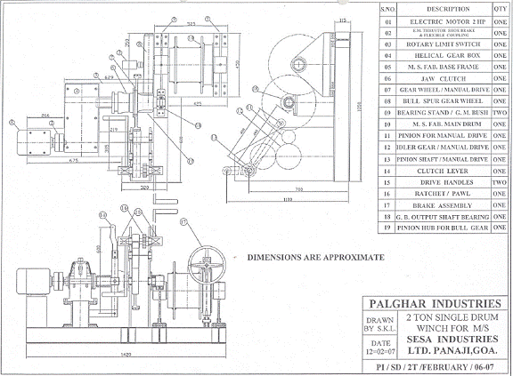
Drawing showing crane and working cage position in front of BF1 GCS during Downcomer patching.
Drawing No. 2200-01505A

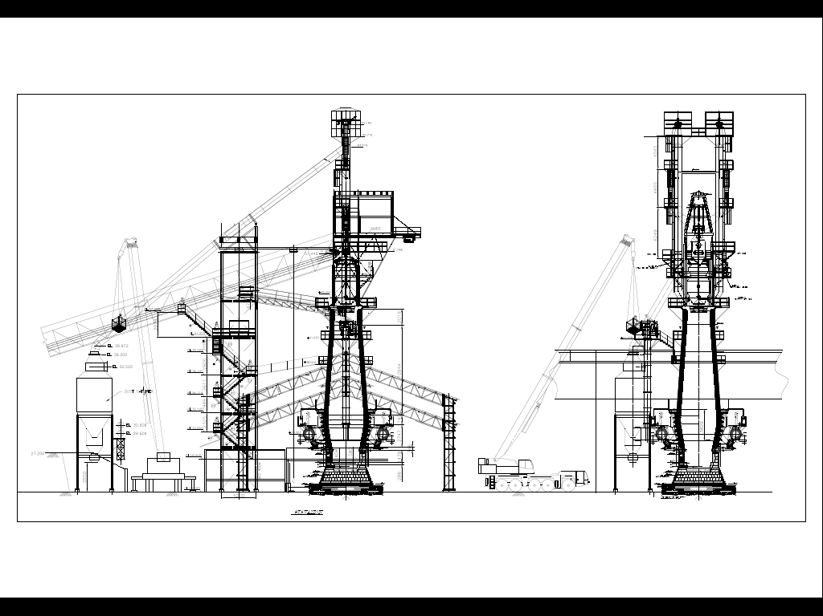

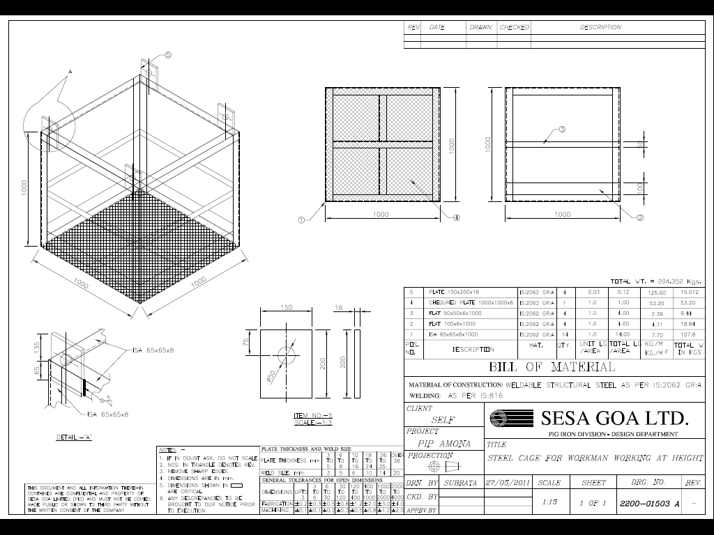

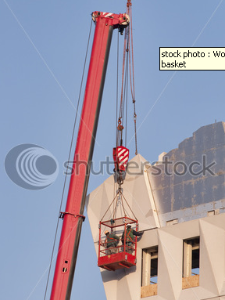

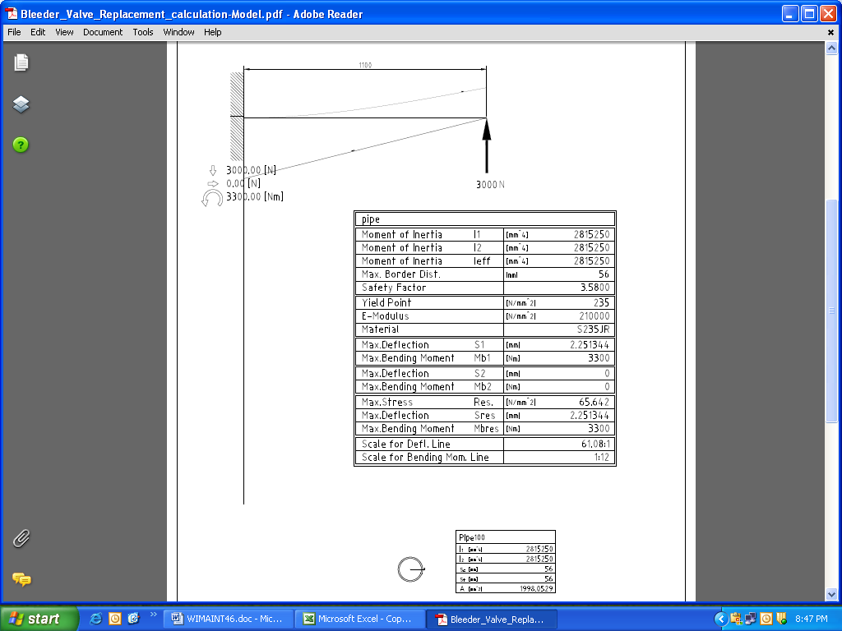

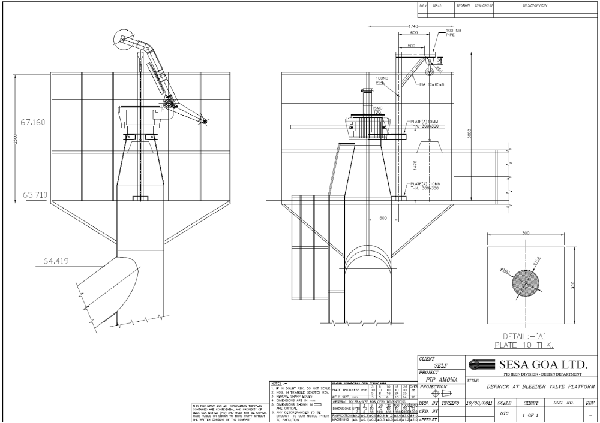

ACTIVITY 3 : EQUILISATION VALVE MAINTENANCE
Work No 1 : Equalization ducting and flange opening
Work No 2 : Replacement of Equalization Valve
Work No 3 : Replacement of Equalization valve cylinder
- Take clearance from production department from the shift Superintendent / in charge.
- Work with CO monitor every time.
- Insert blind plate in above saturator on the EV 2 piping
- Open the relief valve provided at the duct to release the gas & steam purging.
- Ensure that EV 1 is kept open.
Work No 1 : Equalization ducting and flange opening
- Open the flange by removing bolts. Use cutting set to remove the jam bolt as per procedure SP 44.
- Ensure that the ducts are properly supported wherever flanges are opened.
- Clean the inside jams in the duct.
- Operate the Equalization valves and check the seat for proper seating.
- Check the gasket condition of the flange and if required, change the same.
- Fit the flange back to position.
Work No 2 : Replacement of Equalization Valve
- Take the electrical shutdown of 5 HP pump for replacing the cap and seat in position. (During overhauling at the work shop shutdown is not required)
- Remove the flange of the Equalization valve.
- Weld the angle at the both the end of flange. To hold the specified gap so that pipe doesn’t come down by self weight.
- Loosen the bolt and remove the equalization valve. Use cutting set if the bolts are in jam position.
- Fit the overhauled Equalization valve in between the provided gap.
- Check the gap of seat and cap with the feeler gauge
- Access the condition of the gasket and replace if require.
- Ensure proper tightening of the bolt.
- Take the trail of the equalization valve for proper seating and give clearance.
- Shift the remove Equalization valve to the workshop for repair.
Work No 3: Replacement of Equalization valve cylinder
- Take the shutdown of Both 5 Hp pump
- Remove the hoses connection of the cylinder.
- Decouple the cylinder from the Equalization valve arm.
- Remove the one side of the cylinder fork fixing plate and remove the cylinder
- Fit back the overhauled cylinder in the position & couple the cylinder fork with the equalization valve arm with the help of connecting pin. Check cylinder rod threading and fork threading for proper tightness and lock pin during inspection of EV’s
- Lock the pin using split pins.
- Inspect the condition of the hose and nipple. Replace the same if required.
- Fix the hose to the cylinder.
- Clear the electrical shutdown as per shutdown procedure
- Take trial of the Equalization valve cylinder.
- Check for any leakage of oil from the cylinder.
- Perform the house keeping operation as per work instruction for house keeping (WI/MAINT/91)
- For hose replacement follow procedure WI/MAINT/39 for hydraulic system maintenance.
- Follow procedure WI/MAINT/12 for handling of materials.
DO :
- Keep the proper housekeeping at the furnace top.
- Take care to avoid falling of material as the job related is at height.
DO NOT :
Carry loose pieces top the furnace top.

ACTIVITY 4 : ROTARY HOPPER MAINTENANCE
Work No.1 : Rotary hopper maintenance.
Work No. 2 : Rotary hopper liner for vertical thrust roller replacing.
Work No. 3 : Rotary hopper Upper & lower cone replacing.
Work No. 4 : Removal of sheared bolts by drilling with magnetic drill machine.
Work No 5 : Rotary Hopper Chute Hardfacing

Work No. 1 : Rotary hopper maintenance
- Soon after Furnace shutdown (after top firing) put rotary distributor in manual mode in consultation with electrical department.
- Start distributor for five minutes and observe any unusual sound and rubbing sound.
- Take electrical shutdown as per shutdown procedure.
- Open covers of rotary hopper Gearbox and motor and one dust cover in front of gear box. While cleaning, inform people who are on furnace top hatch flange area platform.
- Check oil level of V600 Gearbox and leakages from input/fan side oil seal area
- Check all vertical and horizontal rollers for free rotation and replace damaged rollers.
- Check M16x80 H.T. bolts of liner clamping area, and M16x50 locking bolts of liner with liner housing for looseness.
- Check wear out of main chute near taper cone area and do hard facing of worn out portion of chute and maintain minimum 20 mm gap between upper bell hollow shaft.
- Manually rotate the gear for free movement after thorough cleaning.
- Replace the rollers whichever is not rotating by slightly lifting the gear with jack.
- To replace the gearbox, use 5 T/ 6T hoist after barricading the cast house & removing one roof sheet in the winch side. Follow procedure of top charging equipment WI/MAINT/42 for handling of equipments.
- All the dust covers if removed should be properly kept in platform to avoid fall from height. Fix back the covers as per the numbering.
- Rotate manually the coupling in coupled condition for smooth running; it should rotate freely by one hand.
- For lifting any heavy material from ground follow work instruction given by WI/MAINT/12.
- Apply grease to gear and rollers as per lubrication procedure WI/MAINT/93
- Put cover back and check with electrical section for zero speed.
- Clear shutdown and take trial.
- Check the current of rotary hopper (3 to 4 amps) and motor speed of 900 rpm.
Work No.2: Rotary hopper liner for vertical thrust roller replacing
- Take work permit from production after taking furnace shutdown to go on furnace top & to remove cast house sheets.
- Remove cast house sheets to get clear opening of 2400mm for liner one half to pass through it.
- After going on furnace top check the running of rotary hopper to ensure there is no abnormal sound from gearbox or rotary hopper.
- Take shutdown of rotary hopper, 60 hp pump 1, 60hp pump 2 & CB5.
- Dismantle all covers of rotary hopper.
- Check 5T/ 6T hoist for proper operation with the help of electrical.
- Rotate the rotary hopper in such a way that the joint of liner should come on furnace side & blower side, male joint half should face PCM side & female joint half should face CB5 side.
- Dismantle the gearbox & motor with 5T / 6T hoist / chain pulley block.
- Jack (Maximum 150mm in height) the liner from one side (gearbox side) 10mm above the taper rollers & insert vertically ISMC 125, 200mm long 4 nos equally at 40degrees apart between base for mounting wear ring & ring for fixing horizontal rollers so that load will not come on taper rollers.
- Weld horizontally ISMC 150, 500mm long 3 no equally one in center & others 60degree apart to first piece, for ease of installing sling while removing, do not fix on taper roller bracket portion.
- Remove 3 nos of taper rollers with brackets for ease of removing & installing bolts.
- Remove all the bolts of one half (gearbox side) of the liner & bolts holding both the liners, let liner rest on horizontally welded ISMC 150 channels.
- Pull the liner out sliding on the channel so much that sling could be put in it, put small sling & tie manila rope at the center & hold by 5T/ 6T hoist or chain block.
- Lift the liner by 5T/ 6T hoist / chain block, holding by 6 persons from sides (weight of half liner is 140Kgs).
- Take the liner out of the rotary hopper platform hand railing & lower slowly to make it vertical by holding with 5T/6T hoist & 6 persons.
- Remove all persons in the cast house & lower it in cast house using 5T/6T hoist.
- Lift the new liner with female joint & lower it horizontally on ISMC 150.
- Fix all the bolts (0623120037- M16 x 200 countersunk bolts) & tighten counter sunk bolts till head goes in the liner (Don’t tighten it fully so that it can be adjusted while fixing other liner).
- Fix back removed taper rollers with bracket & remove ISMC 125 fitted in step 8 so that rotary hopper can be rotated by 180degrees.
- Rotate rotary hopper by 180 degree & repeat steps 9 to 19 for fixing other half of liner with male joint.
- Once male joint liner is taken on ISMC 150 channel match it first with female part & fix side bolts, than fix all other countersunk bolts.
- If any hole is not matching after all possible trials than use M12 x 200 mm long counter sunk bolt.
- Tighten all bolts & fix double nut on it. Tack weld the nut to bolts on top.
- Refer SP44 Operational Control
- For lifting any heavy material from the bottom follow instruction given by WI/MAINT/12.
- Replace all six taper rollers, since new liner plate is replaced.
- Put gearbox & motor in position, align & couple.
- Clear shutdown & take trial of rotary hopper.
- Fit back all the rotary hopper covers, take trial & clear all other shutdowns & clear work permit.

Following material to be kept ready before taking the job:
- ISMC 125, 200mm long - 4 no
- ISMC 150, 500 mm long - 3 no
- Hydraulic / Mechanical jack, maximum height 150mm – 2 no
- 0623120037- M16 x 200 countersunk bolts – 24 no
- M12 x 200 countersunk bolts – 10 nos
- Sling 1000 mm x 12 mm – 2 no
- D shackles 2T – 2 no
- Manila rope 12 mm – 20 mts.
- Rough flat file – 01 no
- 12 – 14 mm Rod 500mm long with handle not to pass through grating for centering holes – 2 no
- Required spanners, chisel, safety belts
- 2T chain block – 1 no
- Taper rollers – 6 no
- Standard made sling to put on rotary hopper gearbox to lower – 01 no
- J bolts to fix back sheets of cast house – 18 no

Work No.3: Rotary hopper Upper & lower cone replacing
- Take work permit from production after taking furnace shutdown to go on furnace top.
- Check the running of rotary hopper to ensure there is no abnormal sound from gearbox or rotary hopper.
- Take shutdown of rotary hopper, 60 hp pump1, 60 hp pump2 & CB5.
- Put chain block to lower bell shaft & upper bell shaft –safety
- Cut the fixed chute above the rotary hopper, also check if the diversion plate below CB5 head drum is required to be removed to replace rotary chute.
- Dismantle all covers of rotary hopper.
- Remove the clamp of wear ring & remove the wear rings up to lower cone level for ease of removing lower cone.
- Check 5T/6T hoist for proper operation.
- Put a hole on the upper cone one half & using chain block dismantle upper cone repeat the procedure for other cone.
- Put a hole on lower cone one half & using chain block dismantle lower cone repeat the procedure for other cone.
- Use 5T/6T hoist / chain block to replace upper & lower cones.
- Insert one half of lower cone with chain block & bolt the same on the brackets then insert another half of lower cone bolt on the bracket by adjusting the cone for all bolts insertion, then put bolts for mating brackets of both lower cone.
- Repeat the steps no.12 for upper cone. Ensure intermediate stool connectors are fitted to intermediate stools.
- Tighten all bolts connecting lower cone, upper cone. Weld vertical supports of 65 x 65 ISA connecting intermediate stool and upper cone chute. Clear all other shutdown & take trial of rotary hopper.
- For lifting any heavy material form the bottom follow instruction given by WI/MAINT/12.
- Again take shutdown of rotary hopper & put all wear rings in position & check for rotary chute touching the wear ring, in case it is touching using gauging rod – (1902030024 - ELECTRODE,AS,LOTHERME 801,4MM) gauge the portion touching the wear ring, again check the clearance by rotating the cone with hand.
- Take trial of rotary cone after fixing wear rings.
- Fix back fixed chute which was removed step no.5, if diversion plate below CB5 is removed fit it back.
- Fit back all the rotary hopper covers, take trial & remove all chain blocks, clear all other shutdowns & clear work permit.

Work No.4: Removal of sheared bolts by drilling with magnetic drill machine.
- Take work permit from production after taking furnace shutdown to go on furnace top.
- Check the running of rotary hopper to ensure there is no abnormal sound from gearbox or rotary hopper.
- Take shutdown of rotary hopper, 60 hp pump1, 60 hp pump2 & CB5.
- Shift the Magnetic drill machine (single phase) on furnace top at rotary hopper from CB5 walkway. 2 persons should carry the machine with a rod and machine to be locked properly on rod while moving up and down the walkway to prevent it from sliding. Connect extension board from TCPP room single phase point to rotary hopper or from other single phase outlet provided by electrical near rotary hopper.
- Dismantle one or two top covers of rotary hopper and clean the rotary distributor gear with air .
- After cleaning identify the bolts of guide plate which are to be removed.
- Remove the guide plate by removing bolt or by gas cutting the tack weld.
- Mount the magnetic drill machine on gear of rotary hopper and centre the required size (M14) of drill bit exactly on the sheared bolt. Lock it in position by energizing the magnet of drill machine.
- Only trained personnel should operate the machine. All safety PPE’s should be used. Safety belt to be used by person while drilling if drilling is done by standing on gear.
- Drill the hole to required depth (45 mm) and clean the hole of sheared bolt after removing cut chips.
- Shift the drilling machine aside.
- Use M16x 2 pitch tap set and tap the hole with tap wrench using oil.
- After tapping put M16 bolt and check.
- Remove the bolt and fit the removed top guide plate of horizontal roller. Put the bolts and tighten it.
- Fit the rotary hopper top covers. Clear the shut down and take trial.

Work No.5: Rotary Hopper chute Hardfacing

- Take clearance from Production department
- Take electrical shutdown of CB#5 (both Motors), 60 HP Both, 5 HP both pumps & Rotary Hopper
- Safety Harness compulsorily to be used while working in rotary hopper chute
- Check wear out of main chute near taper cone area and do hard facing of worn out portion of chute and maintain minimum 20 mm gap between upper bell hollow shaft.
- Clear Shutdown and take trials

ACTIVITY 5 : TOP HATCH OPENING/CLOSING DURING FURNACE SHUTDOWN

Work No 1 : Top hatch opening
Work No 2 : Top hatch closing

Work No 1 : Top hatch opening
1. This job is to be done during s/d of BF-s. Take clearance from production for top hatch opening.
2. Do carry CO detector and monitor it continuously
3. After production clearance, remove the wedges of the top hatch, one by one by using hammer and remove the pins.
4. Put one pin from top, preferably the bottom pin.
5. Slide the hatch from the side by standing away while opening.
6. Care should be taken that the person opening top hatch should not stand directly in front of the hatch.
7. Keep the mesh on the opening after top firing.
8. Keep the removed wedges and pins at one location so that they are not misplaced.

Work No 2 : Top hatch closing
1. Take clearance from production for top hatch closing.
2. Monitor Co level continuously.
3. Inspect the graphite rope of top flange for its good condition. If required, Change the rope with 12mm square graphite coated rope.
4. Check the condition of inspection door, wedges and pin if found damaged replace the same. If the wedges sides are blunt grind the same as per Work instruction WI/MAINT/30
5. Slide the inspection hatch back to position, matching all the cover holes and insert pin-keeping pinhead below and wedge slot above.
6. Insert the wedge in pin such a way that wedges matches the profile of pin and hammer till it is fully tight. Ensure that the wedge area fully covers the inspection hatch.
7. Follow the same procedure for fixing all the pins/wedges.
8. Ensure that all pins and wedges are fully tightened.
9. Give clearance to production.
DO:
- Monitor Co level continuously.
- Change the rope with 12mm square graphited rope in planned shutdown.
- Put mesh after opening inspection door.
DO NOT:
 Stand in front of inspection hatch while opening.

ACTIVITY 6 : PROCEDURE FOR TOP SPRAY CHECKING/CLEANING

Work No 1 : Procedure for furnace top sprays cleaning /checking

- Take furnace shutdown.
- Remove the nut & bolts of all 04 nos flanges at top hatch platform. If bolts are tight use gas cutting set and gas cut the bolts. Ensure not to move with the lighted torch from one flange to another.
- Take the sprays out keeping the valve closed. Check the sprays for choking or any damage.
- If found choked clean the same by removing the spray from hose and back flushing it.
- Inform production engineer to take trial of sprays. Hold the spray at valve end and rest the spray on hand railing 50mm (flat bar) with spray end pointing outside.
- Open the valve and check for free and proper pressure spray of water from all sprays one by one.
- Trials of the sprays has to be shown to operational engineer available in furnace top.
- After confirming the sprays close the valve and fit them back. If gasket 100 NB is damaged replace the same. Ensure water does not enter the furnace. Also check & replace the damaged hoses.
- While tightening the bolts ensure your hand fingers does not get trapped in between spanners. Lock the nut with D spanner and tighten the bolt by ring spanner (24/27).
- Give clearance to operational team after completing the job.

ACTIVITY 7 : STOCK ROD FIXING

Work No 1: Stock rod changing

Work No.2: Stock rod wire rope changing.

Work No 3: Stock rod pulley changing at top.

Work No 4: Stock rod cylinder changing.

Work no 5: Auto Stock rod wire rope changing

Work No 6: Auto Stock rod SS wire rope changing

Work No 7: Auto stock rod counterweight changing

Work no 8: Auto stock rod cordon shaft changing

Work no 9: Auto stock rod gate valve changing.

Work no 10: Stock rod overhauling.

Work no 11: Auto stock rod assembly and dismantling

Work No 1: Stock rod changing
- Check the new stock rod for its overall length of 4200 mm.
- Take clearance from production department for changing the stock rod . This activity is to be carried out only during the shutdown of blast furnace.
- Hold the eye of the stock rod coinciding with the arrow mark fixed on the charging hopper by lifting the stock rod
- The distance from the crown ring to the arrow shall be 1776mm.
- Air line has to be closed for the pneumatic stock rod and solenoid coil has to be removed to prevent operation of the cylinder.
- While stock rod is inside the furnace remove the d-shackle from top.The removed wire rope is supported with the hook provided at the four pole column to prevent wire rope snapping due to entanglement with the pulley.
- Remove the stock rod flange and take it out with manilla rop and pour water on it to cool the stock rod.
- Put back overhauled stock rod using manilla rop and tighten the flanges.Wire rop has to be connected to the stock rod using d-shacke .Lock the d-schackle with split pin.
- Check the pointer (counterweight) in the control room coinciding with the zero level.
- If the level of the counterweight is not coinciding with "O" ring level, adjust the level by releasing the clamp.
- Normalise the stock rod by fixing back the solenoid coil and opening the air supply.
- Operate from control room for free movement of the stock rod.
- Check the verticality of the stock rod with respect to top rope pulley.
- Check for parallelity of stock rod inserting pipe flange for 0-0 level.
- Check for free rotation of both the pulleys on furnace top.
- Follow the housekeeping procedure as per instruction given WI/MAINT/91.
- Check the 2 nos pulleys of stock rod for its freeness.

Work No.2: Stock rod wire rope changing.
- This activity is to be carried out only during shutdown of blast furnace Check for rope damage at furnace top and cast housetop.
- In case rope strands found damaged, follow the following procedure.
- Release fully the stock rod inside the furnace.
- Remove the D Shackle from the stock rod eye end.
- Open the bulldog clamps at the rope end and release the rope from the top pulleys and slowly lower the wire rope on cast house roof sheet with manila rope and disconnect other end of the rope from the control room bracket.
- Use new wire rope (diameter 12mm) and maintain rope length loop-to-loop 31.79m for BF#1 and 33.3m for BF#2.
- Take the new wire rope to furnace top. Open one end bulldog clamps and pass it through 2 pulleys and connect to the stock rod eye end and maintain the same distance of the loop as previously set.
- Drop other end of the wire rope through cast house top pulley and connect to the control room bracket.
- Operate the stock rod from control room and check for set dimension as per Sr. no. 3 and 4 of Work No.1(stock rod changing)
- Show the stock rod levels to Instrumentation, shift superintendent or Manager Production during trials.

Work No 3: Stock rod pulley changing at top:
- Take clearance from production department for changing the stock rod pulley Take stock rod inside the furnace and release the load on the pulley.
- Cut all the locking bolts and check the thickness of the plate, which is welded to the beam.
- Replace the top pulley and connect wire rope to the stock rod.
- Take trial of the stock rod 3 to 4 times and check for free movement of pulleys.

Work No 4: Stock rod cylinder changing.
- Take clearance from production department for changing the cylinder Take the stock rod inside the furnace if furnace is under shutdown. If the furnace is in opearation,then stock rod needs to be put in manual mode or pulled out of furnace from control room and lock the counterweight pointer with a properly secured pipe / properly bend lancing pipe.
- Close the air valve; release the air, which is inside the cylinder by removing hose.
- Remove the D shackle holding wire rope connected to cylinder fork.
- Replace the cylinder with end bracket.
- Connect the hose, D shackle and wire rope. Check cylinder for any leakage.
- Take trial 3 to 4 times and hand over to production.

Work no 5: Auto Stock rod wire rope changing.
- This activity is to be carried out only during shutdown of blast furnace with work permit
- Check for rope damage at furnace top and cast house top.
- In case rope strands found damaged, follow the following procedure.
- Put auto stock rod in manual mode and bring the stock rod out of furnace.
- This will bring the counter weight above the gate valve.
- Close the gate valve and slowly lower the stock rod manually to make it rest on valve gate.
- Take shut down of auto stock rod motor.
- Count the wire rope rounds on drum at furnace top, at cast house and open the clamps of drum to remove wire rope.
- Put new wire rope (Diameter 8mm-37 mtr long) on drum with same no.of rounds and tighten the rope clamps on drum.
- Guide the remaining wire rope from pulley to cast house from roof sheets.
- Safety belt to be put while working on sheets to guide the wire rope.
- Count the wire rope rounds on drum in cast house and open the clamps to remove the wire rope.
- Wound the new wire rope on drum and tighten the clamps.
- Clear the shut down of motor.
- Slightly raise the stock rod from rest position in manual mode
- Open the gate valve and lower the stock rod inside furnace.
- Take trial and check the stock rod levels.
- Show the stock rod levels to Instrumentation engineer as well as to production shift superintendent or Manager Production during trials.

Work No 6:Auto Stock rod SS wire rope changing
1.This activity is to be carried out only during n shutdown of blast furnace
2. Open the inspection door above gate valve at top hatch platform and inspection door at rotary hopper platform
3.Select the auto stock rod motor in manual mode and operate the auto stock rod from cast house and bring it above the gate valve by coordinating with engineer in charge for furnace top (resp: Productionn. Close the gate valve once the counter weight is above valve. (resp: maint. Engineer)
4.Take the counter weight out from inspection door and lower it on top hatch platform till the tension on wire rope is released
5 Adjust the wire rope drum position in such a way that the clamps on drum are accessible.
6 Remove the wire rope from counter weight thimble by opening bull dog clamps and count the number of wire rope rounds on drum.
7.Remove the clamps on wire rope drum and remove the wire rope.
8.Put new wire rope (13 mtrs) on drum with exact number of rounds and connect other end of wire rope to thimble of counter weight.
9.Check for tightness of bull dog clamps and drum clamps.
10.Slowly lift the counter weight by operating the motor, inching it till counter weight is put in inspection door.
11.Open the gate valve.
12.Lower the counter weight in furnace and adjust the stock rod level with manual stock rod .
13.Close both inspection doors.
14.Show the stock rod levels to Instrumentation, shift superintendent or Manager Production during trials.
15.Put the system in Auto.

Work No 7:Auto stock rod counterweight changing
1. This activity is to be carried out during shutdown of blast furnace .
2. Shift the new counter weight fitted with thimble to furnace top hatch platform with the help of 6T/5T hoist of furnace top.
3. Open the inspection door above gate valve at top hatch platform.
4. Put the auto stock rod motor in manual mode and operate the auto stock rod from cast house and bring it above the gate valve by coordinating with furnace top engg. Close the gate valve once the counter weight is above valve.
5. Take the counter weight out from inspection door and lower it on top hatch platform till the tension on wire rope is released.
6. Open the bull dog clamps and remove the wire rope. Keep the counterweight aside and replace it with new counterweight fitted with thimble. Put the wire rope and tighten the bull dog clamps
7. Lift the counterweight by operating the motor slowly from cast house and in coordination with Production engineer responsible for furnace top .

8 Adjust and put the counterweight in inspection door and keep lifted up from valve.
9. Open the gate valve and lower the counterweight by operating the motor.
10. Take trials and check the stock rod levels.
11. Show the stock rod levels to Instrumentation, shift superintendent or Manager Production during trials
12. Close the inspection door and put the system in auto.

Work no 8: Auto stock rod cordon shaft changing
1. This activity is to be carried out during shutdown of blast furnace.
2. Open the inspection door at rotary hopper platform.
3. Put the auto stock rod motor in manual mode and operate the auto stock rod from cast house and bring it above the gate valve by coordinating with furnace top engg. Close the gate valve once the counter weight is above valve.
4. Close the gate valve and lower the counterweight so that it rests on gate valve and tension on 16mm wire rope and drum is released.
5. Take shut down of motor and then rotate the wire rope drum in cast house by releasing the brake manually, to release the tension on 8mm wire rope and drum at furnace top is released.
6. Remove the cordon shaft guard and remove the cordon shaft by opening the flange joint of cordon shaft.
7. Replace it with new cordon shaft and put the guard back.
8. Clear the shutdown of motor and operate the motor to lift up the counterweight from gate valve. Open the gate valve and lower the counter weight.
9. Take trials of stock rod.
10. Put the system in auto.

Work no 9;Auto stock rod gate valve changing.
1. This activity is to be carried out during shutdown of blast furnace
2. Open the inspection door above gate valve at top hatch platform.
3. Put the auto stock rod motor in manual mode and operate the auto stock rod from cast house and bring it above the gate valve by coordinating with furnace top engg. Close the gate valve once the counter weight is above valve.
4. Take the counter weight out from inspection door and lower it on top hatch platform till the tension on wire rope is released
5 Put Sling above 16mm wire rope drum unit and hang a tested 3T chain pulley block. Put another sling around the drum unit and take load of unit on chain pulley block.
6 Remove or gas cut the gate valve flange bolts and remove the valve. Replace it with new valve 150 NB and put the bolts and tighten. Replace the gaskets in between flanges.
7. Valve assembly can be replaced by removing it from bonnet and replacing it with new bonnet assembly. For this step no 5 is not required.
8. Take trial of valve for proper closing and opening.
9. Keep the valve closed and put the counterweight inside the inspection door by operating the motor slowly from cast house and in coordination with furnace top engg.
10. Open the gate valve and lower the counterweight inside furnace.
11. Close the inspection door and take trials of stock rod.
12. Put the system in auto.

Work no 10: Stock rod overhauling
- Shift the stock rod to be overhauled from bottom of stock rod stand kept in front of drill bit shed to mechanical workshop by hand.
- Keep it on stock rod overhauling stand and place two manual screw jacks at either ends of it for leveling the stock rod.
- Check the flange bush for wear out.
- If worn out gas cut the stock rod at the portion where it has worn out and remove the flange. Gauge both the cut rod ends to form V-joint. If require replace the rod piece at worn out portion.
- Place the removed flange on template and mark the bush portion (80mm OD). Remove the flange out of template and gas cut the marked portion. Again place the flange on template and fit the machined bush (80mm OD, 44mm ID & 20mm Thick) and weld. Grind the welded portion using hand grinder.
- Put the overhauled flange, aligned the rod joint and tack weld it.
- Check the overall length of stock rod. It should be (4200 mm).
- Then fill the joint by welding. Rotate the stock rod from one end simultaneously for achieving equal distribution of welding.
- Then grind the welded portion of rod with hand grinder. Rotate the rod simultaneously to achieve smooth finish.
- Fit the diameter checking gauge (40mm ID)on rod and move it along the length. If the gauge passes all over the length and joint of rod smoothly then the rod is ok. If not then grind the portion of rod where the gauge gets stuck and check again.
- Shift the stock rod after overhauling from mechanical workshop and keep it on top of stock rod stand.
- Follow the house keeping procedure as per instruction WI/MAINT/91.

Work no 11: Auto stock rod assembling and disassembling

Disassembling:
- This activity is to be carried outonly during shutdown of blast furnace Open the inspection door above gate valve at top hatch platform.
- Put the auto stock rod motor in manual mode and operate the auto stock rod from cast house and bring it above the gate valve by coordinating with furnace top engineer. Close the gate valve once the counter weight is above valve.
- Tie manila rope to the counter weight at bottom and guide it out from inspection door and lower it on top hatch platform by operating the auto stock rod motor. If spare counter weight is available & old counter weight is not required then the 16mm SS wire rope holding counter weight can be gas cut and counterweight can be put inside furnace.
- Take electrical shutdown of auto stock rod motor once the above activity is over.
- Remove the guard over cordon shaft and decouple cordon shaft from 8mm wire rope drum and 16 mm wire rope drum assembly.
- Open the inspection door of 16mm wire rope drum unit. Remove or gas cut the casing flange bolts of top half cover if cannot be opened by spanners. Remove the remaining 16 mm wire rope from drum by rotating the drum manually. If drum is jammed then remove wire rope by lifting the counterweight side end and unwind it off the drum.
- Open the Plummer block of both sides and hang a 3T tested chain pulley block from rotary hopper platform support above 16mm wire rope drum unit. Put wire rope sling (3T) or belt sling (3T) to 16mm wire rope drum and remove it. Keep it on fixed hopper platform and with the help of 6T/5T furnace top hoist lower it to cast house.
- Put the sling now to bottom half of the casing. Remove the top flange bolts of vertical inspection door 150 mm pipe and remove the bottom half casing. Shift it to cast house with 6T/5T furnace top hoist.
- Then put the sling to the vertical inspection door pipe and remove the bottom flange bolts (above the 150NB gate valve). With the help of chain pulley block lower it to top hatch platform. From there lower it to cast house by 6T/5T F/Top hoist.
- Remove the 150 NB gate valve. Put dummy flange with gasket on top of distance piece.

Assembling:
- First lift the gate valve 150 NB from cast house by 6T/5T F/top hoist and place it on top hatch platform.
- Then remove the dummy flange of distance piece. Lift the gate valve using manila rope and place it to position. Put the bottom flange bolts and tighten it.
- Then lift the 16mm wire rope drum assembly with casing from cast house by 6T/5T F/top hoist and keep it at top hatch platform. With 3T chain pulley block fitted at fixed hopper platform lift the casing assembly and place it in position. If require cut the platform / gratings that obstructs the casing while lifting. Do not cut the supporting channels of casing mounting.
- Check the distance between bottom flange of casing and top flange of gate valve. This distance is required to fit the vertical pipe with inspection door. If the distance is (1910 mm) lift the vertical pipe with 3T chain pulley block and position it.
- If the distance is not ok lift the casing assembly by providing packing below it.
- Then lift the vertical pipe with inspection door using 3T chain pulley block and sling. Position it in place, put gasket and bolts to bottom flange of vertical pipe.
- Lift the casing assembly and remove the packing provided.
- Do bolting of casing bottom flange and vertical pipe top flange by replacing gasket.
- Then couple the cordon shaft with 8 mm wire rope drum and 16mm wire rope drum.
- Fabricate back the platform / gratings that were removed and weld it.
- Follow the housekeeping procedure as per instruction given WI/MAINT/91
- Clear the electrical shutdown and take trials.
- Show the stock rod levels to Instrumentation, shift superintendent or Manager Production during trials.

DO’s :
- Depressurize the stock rod cylinder system before working on the system.
- Ensure release of tension of wire rope before working on wire rope
- Lock the flange with clamp to avoid sliding of flange on rod during transit.
- Cool the stock rod with water before shifting it down from furnace top.
- Ensure that manpower is removed aside from cast house area where wire rope will be dropped from furnace top during replacing.

DO NOT
1. Touch or hold the stock rod with bare hands after removing from furnace.
2. Stand in the swiveling linkage area of stock rod cylinder above control room.
3. Hold the piston rod of cylinder or wire rope while moving

Amendement Record
Date | Manual Section Ref. & Para | Brief details of Revision | New Rev.

Prepared By:  Area Engineer | Reviewed & Issued By:  Management Representative | Approved By:  Mechanical Head
Signature | Signature: | Signature:
Review Date: 12.12.22 | Review Date: 12.12.22 | Review Date: 12.12.22

